Name ____________________________________Date _____________________ Block_______
Pre-calculus Review 1.7-1.9
- Describe the transformation of g(x) = -6(1/2(x-4)³) -2

- Write the function g(x) as a transformation of f(x) if f(x) = x² and it has been horizontally shifted left 8 and vertically shifted down 3.
3. Name the parent function and describe the transformation
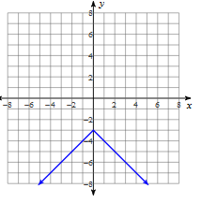

4. Describe the transformation of f(x) to g(x)
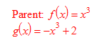

5. The graph of h(x) is below. Determine the parent function, and describe the transformations to the parent function.

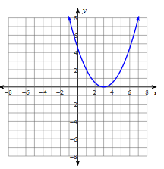

6. Write the equation of each of the functions that is a transformation of the parent cubic function with the following:
- Vertical shrink by ¼.

- Vertical shift down 5.

- Horizontal shrink by ½.

- Horizontal reflection.

7. Graph h(x) = 2(-x)³ + 1 and graph the parent function.
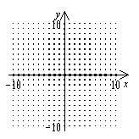

8. Use the parent function, f(x) = $\sqrt{x}$, sketch the graphs of the following functions.
(a) h(x) = $\sqrt{x}$ - 4 (b) k(x) = $\sqrt{x-3}$

9. Write the equation of the transformation of parent function y= [[x]] if it is translated 6 to the left up 7 vertical shrink by 1/5 and reflected over the y- axis

10. Use the following graph to transform the graph into:
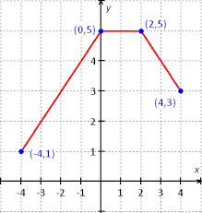

- g(x) = f(-x) b. h(x) = f(x) - 4

11. Describe the transformation of the parent function y= $\left|x\right|$ to y = -3$\left|-(x+2\right|)$

Use for 12-16: f(x) = 3x + 7and g(x)= x² + 2
12. Find (f + g)(x)
13. Find (f – g)(x)
14. Find $\frac{f}{g}$(x) include the domain

15. Find (f o g) (x)

16. Find (g o f) (x)

17. Find for f(x) $\frac{1}{x^{4}}$and g(x) = $x^{6}$.

18. If f(x) = 3x² and g(x) = 2x + 10 , find (g(f(3)) and then

19. Find the inverse of f(x) = 3x + 9; verify using composition. Is f(x) one to one?

20. Find the inverse of the function show all work
f(x) $=\frac{x-3}{4}$

21. Use the Horizontal line test to show whether or not the graph is 1 to 1.
